Note: The information provided in the Expression of Interest (EOI) submission will appear in your online application portal, the information can not be edited.
You are required to complete the remainder of the application prior to submitting.
Stage 2 Full Application requires responses to the following:
Deliverables
- Key Milestones
- Inputs
- Outputs
- Outcomes
- Awareness and Opportunities
Budget
- Confirmed Income
- Unconfirmed Income
- In-Kind Support
- Expenditure
- Project Funding
Sustainability & Evaluation
- Sustainability
- Evaluation
Key Risks & Conflicts
- Key Risks – Organisation
- Key Risks – Project
- Conflicts
HOW TO USE THIS DOCUMENT
- Use this document to assist in the preparation of your application.
- Cut and paste your final responses into the online application form.
- Some questions only require click box / drop down responses in the online application form.

NOTE:
- All applications must be submitted using the Newcastle Permanent Charitable Foundation Application Form portal only.
- WORD / PDF APPLICATIONS WILL NOT BE ASSESSED.

MANDATORY DOCUMENT:
- Applicants submitted a Program Logic Plan during the Stage 1 Application Round. The aim of the program logic plan is to assist the development of your project ‘Theory of Change’ and build your proposal from end to end. The program logic plan plays a key role in predicting the outcomes for your beneficiaries (people you intend to help); what resources you require for your project (inputs), what activities to be delivered (outputs), who should be involved, what should be measured, assumptions, external factors and the short, medium and long term impact (outcomes).
Deliverables
Please outline the Key Milestones for this project, providing as much detail as possible. A minimum of three milestones is required.
Example Key Milestones include vehicle delivered, training commenced, building works commenced, building works completed, media launch, program officially commenced, review completed.

Key Milestones
Key Milestone: Funds paid
Grant paid approximately six months after submission is received if successful.
A minimum of three Key Milestone are required.

Key Milestone 1 (Limit 50 words)
Start Date

End Date

Key Milestone 2 (Limit 50 words)

Start Date

End Date

Key Milestone 3 (Limit 50 words)

Start Date

End Date

Key Milestone 4 (Optional) (Limit 50 words)

Start Date

End Date

Key Milestone 5 (Optional) (Limit 50 words)

Start Date

End Date

Key Milestone 6 (Optional) (Limit 50 words)

Start Date

End Date

Final Key Milestone: Project Acquittal report submitted. Refer Grant Agreement for date if successful.

Project Inputs, Outputs and Outcomes
For Inputs, Outputs and Outcomes refer to your completed Program Logic Plan you submitted in EOI Stage 1.
Example: Available on the Charitable Foundation website
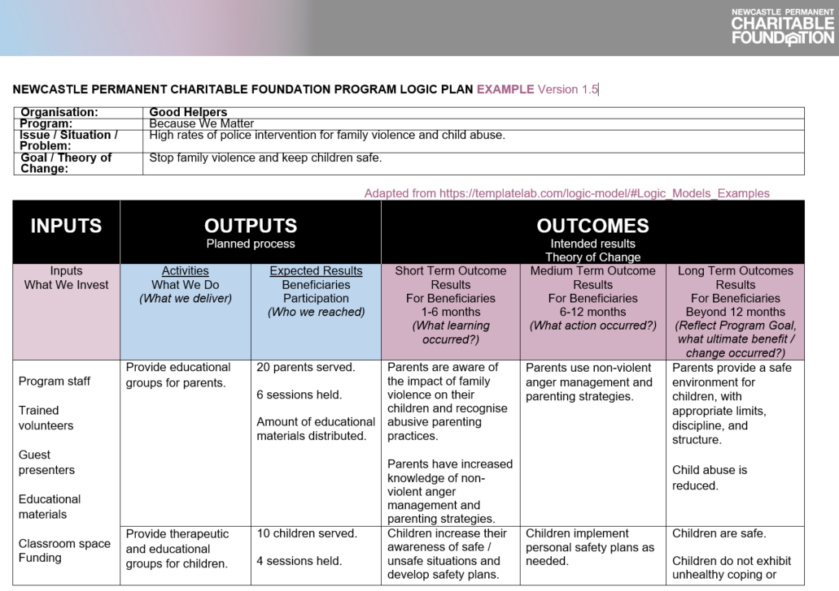
As you work through Stage 2, you may review and update your program logic responses before submitting.
Remember:
Program Logic Plan intends to demonstrate a Theory of Change (behaviour change) for beneficiaries (participants) of the funded project ONLY. Based on assumptions (predications), state what ‘outcome’ change will occur for the beneficiaries / participants? Your long term outcomes should = your goal (refer to the above example, the ‘Goal / Theory of Change’ reflects the ‘Long Term Outcomes’).

The following items do not belong in your ‘Theory of Change’ Outputs and Outcomes: recruiting and training to staff / volunteers, program launch, fundraising, developing MOUs / In-Service Agreements, co-designing, consultation, community engagement / development, building / infrastructure design, Council DA applications, attending meetings, graphic design. These are either recorded in your in your Key Milestones Deliverables or separately in your organisational workflow plan.

Once you have finalised your program logic plan, cut and paste your final responses into the relevant sections in the Stage 2 online portal, note you will also be required to attach your program logic plan (word version only) to your online application.

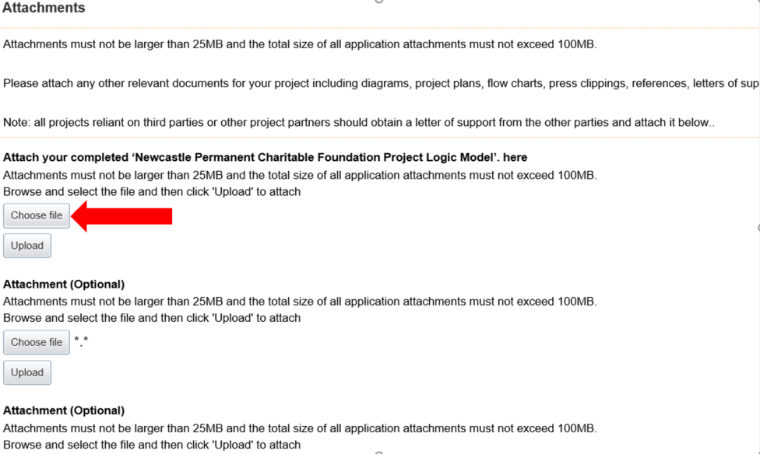

Attachments
Mandatory Attachment – Word version only.
Attach your completed ‘Newcastle Permanent Charitable Foundation Project Logic Model’.

Attachments must not be larger than 25MB and the total size of all application attachments must not exceed 100MB.

Please attach any other relevant documents for your project including diagrams, project plans, flow charts, press clippings, references, letters of support.
Note: all projects reliant on third parties or other project partners should obtain a letter of support from the other parties and attach it here.
4 ‘optional’ attachments permitted.

Optional attachments must not be larger than 25MB and the total size of all application attachments must not exceed 100MB.
Optional Attachment 1:
Optional Attachment 2:
Optional Attachment 3:
Optional Attachment 4:

Awareness and Opportunities
How will your project be promoted and how will Newcastle Permanent Charitable Foundation's support be acknowledged? (Limit 200 words)
Consider media events, signage, acknowledgements on collateral and websites, newsletters, social media, case studies

Will your project utilise volunteers?
[Drop down box selection in the online application form]
Yes / No
If yes, provide skilled volunteer hours estimate

If yes, provide unskilled volunteer hours estimate

Are there any opportunities to engage Newcastle Permanent staff in this project?
If so, what activities would they be involved in?
[Drop down box selection in the online application form]
Yes / No
If so, what activates would they be involved in?

Budget
Unless stated as optional, a response is required for every question.
Note: In the online application, enter numbers as a whole amount e.g. 10000 and do not use any characters in the amount field including commas, $, and full stops.
Confirmed Income
Please include all confirmed income for the project including other confirmed grants, completed fundraising, and own funds contributed.
ALL AMOUNTS MUST INCLUDE GST.

Funding Source | Amount (inc GST)
Total confirmed income

Unconfirmed Income
Please include all unconfirmed income including grants applied for but not approved, fundraising yet to be undertaken.
ALL AMOUNTS MUST INCLUDE GST
Funding Source | Amount (inc GST)
Amount requested from Newcastle Permanent Charitable Foundation is automatically applied here.
Total confirmed income

In-Kind Support
Description | Amount (inc GST)
Total in-kind support

Expenditure
Please include all expenditure on the project below.
Expenditure line items may be rolled up into categories for simplicity if required.
Description | Amount (inc GST)
Total Expenditure
Balance (total income less total expenditure)

Project Funding
Is NPCF a Sole Funder or Major Funder of the project?
[Drop down box selection in the online application form]
Yes / No
If NPCF is not the Sole Funder provide details including other contributors. This should also be reflected in the income section of your budget (Optional)

Budget Attachments
Attach any documents relevant to your project budget including major quotes or details.
Attachments must not be larger than 25MB and the total size of all application attachments must not exceed 100MB.
Browse for the file, select the file, and then click 'upload'.
Optional Attachment 1:
Optional Attachment 2:
Optional Attachment 3

Sustainability & Evaluation
Sustainability
How will your project be sustainable in the long term when this funding concludes, or, if not sustainable how does it ensure an enduring impact on its beneficiaries and the community? (Limit 200 words)

Evaluation
Successful grant recipients may use the following resources that build on the Newcastle Permanent Charitable Foundation Program Logic Model Template.
- Newcastle Permanent Charitable Foundation Program Logic Plan Monitoring Questions & Indicators Template (builds on your completed Program Logic Plan)

- Newcastle Permanent Charitable Foundation Program Logic Plan Monitoring & Evaluation (M&E) Plan Template (builds on your completed Program Logic Plan and Program Logic Plan Monitoring Questions & Indicators Plan)

- Final Evaluation Report Template (reports on the Program Logic Plan, Program Logic Plan Monitoring Questions & Indicators plan and Monitoring & Evaluation (M&E) Plan)
How will you evaluate your project? What type of evaluation do you propose to use? How will you determine the impact on beneficiaries, their families and the wider community? How will your project impact people in need in the future? Provide details of the types of data gathering processes, for example, pre and post surveys, focus groups, digital results, attendance records. (Limit 250 words)

Key Risks & Conflicts
Key Risks – Organisation
Please detail the key risks for your organisation. A minimum of two Key Risks are required.
Example: economic, compliance, security and fraud, financial, reputational, operational, governance, competition risk, this could include; investigations, compliance orders, interruption to business, Public Health Orders.

Organisation Key Risk 1 (Limit 60 words) | How will Risk 1 be mitigated?  (Limit 60 words)
Organisation Key Risk 2 (Limit 60 words) | How will Risk 2 be mitigated?  (Limit 60 words)
Organisation Key Risk 3 (Limit 60 words) (Optional) | How will Risk 3 be mitigated?  (Limit 60 words)
Organisation Key Risk 4 (Limit 60 words) (Optional) | How will Risk 4 be mitigated?  (Limit 60 words)
Organisation Key Risk 5 (Limit 60 words) (Optional) | How will Risk 5 be mitigated?  (Limit 60 words)
Key Risk 6 (Limit 60 words) (Optional) | How will Risk 6 be mitigated?  (Limit 60 words)

Key Risks & Conflicts - Project
Please detail the key risks for your project. A minimum of two Key Risks are required.
Key Risks for the project could include loss of key person; failure of contingent funding application; refusal of development approval; low public interest, reliance on third party to deliver project or provide financial support. Consider your ‘Assumptions’ you recorded in your Program Logic Plan.
Project Key Risk 1 (Limit 60 words) | How will Risk 1 be mitigated?  (Limit 60 words)
Project Key Risk 2 (Limit 60 words) | How will Risk 2 be mitigated?  (Limit 60 words)
Project Key Risk 3 (Limit 60 words) (Optional) | How will Risk 3 be mitigated?  (Limit 60 words)
Project Key Risk 4 (Limit 60 words) (Optional) | How will Risk 4 be mitigated?  (Limit 60 words)
Project Key Risk 5 (Limit 60 words) (Optional) | How will Risk 5 be mitigated?  (Limit 60 words)
Project Key Risk 6 (Limit 60 words) (Optional) | How will Risk 6 be mitigated?  (Limit 60 words)

Conflicts
Are there any actual or potential conflicts of interest that Newcastle Permanent Charitable Foundation should be aware of?
For example, do you know a Newcastle Permanent Charitable Foundation Board Director? Do you have a funding relationship with a competing organisation or financial institution?
[Drop down box selection in the online application form]
Yes / No
If yes, please provide details (Optional) (Limit 100 words)

PROJECT CATEGORISATION
How many people will your project impact directly?
For example: clients served or people trained as a direct result of the grant.
X
- How many people will be indirectly impacted by your project?
For example: families of clients that are beneficially impacted by the project.
X
- Type of project
The project will must align with one or more project types below.
[Click box selection in the online application form]

Early Intervention Program  Vehicle - Community Transport  Vehicle - Special Purpose  Awareness/Community  Education  Outreach Program  Capacity Building for Organisation  Pilot Program  Infrastructure - used by the organisation  Infrastructure - used by the community | Targeted  Intervention/Therapy  Arts and Culture  Disability – Therapy  Disability – Inclusion  Technology – improved  communication (e.g. telecommunication, website)  Technology – Specific  Purpose  Building Project – Refurbishment or improvement  Building Project – New structure or Building | New Equipment – Retained by Organisation  New Equipment – Distributed to end recipients  Camp  Scholarship  Social Enterprise  Emergency/Rescue or Disaster Preparedness  Community Improvement or Social Inclusion

- OTHER: If your project fits another Type of Project provide details here (Limit 10 words)
- Select the Local Government Areas impacted by your project.
Your project will need to operate in at least one of the below Local Government Areas.
[Click box selection in the online application form]
Central West  Bathurst Regional  Bland  Blayney  Cabonne  Cowra  Forbes  Lachlan  Lithgow  Mid-Western Regional  Oberon  Orange  Parkes  Weddin  Western Plains Regional  Greater Metro Sydney  Hunter  Cessnock  Dungog | Lake Macquarie  Maitland  Mid-Coast  Muswellbrook  Newcastle  Port Stephens  Singleton  Upper Hunter Shire  Northern  Armidale Regional  Glen Innes Severn  Gunnedah  Liverpool Plains  Tamworth Regional  Uralla  Walcha  Northern West  Gilgandra  Narromine | Warrumbungle Shire  Richmond-Tweed  Ballina  Byron  Kyogle  Lismore  Richmond Valley  Tweed  Mid North Coast  Bellingen  Clarence Valley  Coffs Harbour  Kempsey  Nambucca  Port Macquarie-Hastings  Central Coast  Hawkesbury  State-wide

- Will your project target a specific gender identity?
[Click box selection in the online application form]
Select one or more as applicable.
No specific target
Female
Male
Transgender Female
Transgender Male
Prefer to describe as other (please specify)
- Please describe your target gender here if you selected ‘Prefer to describe as other’ above. (Limit 15 words)
- Will your project target a specific age group?
[Click box selection in the online application form]
Select one or more as applicable.

All Ages  Babies (0-2)  Early Years (3-6)  Children (7-12)  Adolescent (13-17) | Older Youth (18-25)  Adults  Older people (65+)  Not applicable

- Will your project target a specific cultural group?
[Click box selection in the online application form]
Select one or more as applicable.

Which cultural group does the project mostly target?
No specific target
Culturally and Linguistically Diverse (CALD)
Aboriginal
Torres Strait Islander

Declaration
By submitting this application, I declare that:
- The information in this application is accurate and complete.
- All patrons, company directors and members of the executive team have not been banned or disqualified by the Australian Securities & Investments Commission (ASIC). Search here if unsure.
- The organisation has not been convicted of financial mismanagement including fraud or corruption.
- The organisation have not suspected financial mismanagement.
- I’ve read the funding guidelines available here on our website.
- I am authorised to submit this application.
- I have read the sample Funding Agreement available here on our website.
- I have read and agreed to the terms of the privacy and personal information notification and consent.

I understand and agree that:
- I may be contacted for further information about this application by Newcastle Permanent Charitable Foundation Company Limited (“the Foundation”) and the Foundation may disclose information in this application to other parties in the process of evaluating this application.
- If approved, the applicant must enter into a Funding Agreement before a grant will be provided. The Funding Agreement sets out the conditions of funding and will form the basis of a legally binding agreement between the Foundation and the successful applicant(s) unless otherwise determined by the Foundation. The Funding Agreement is updated by the Foundation from time-to-time and may change between the time you submit this application and its approval (if approved). A legally binding agreement will not be formed until a Funding Agreement is executed by the Foundation and the successful applicant(s).

